**YhcB, a conserved DUF1043 protein, is a Global Response Regulator in Proteobacteria**

**Jitender Mehla1,** George Liechti2**,** Randy Morgenstein3**,** Neha Sakhawalkar1, J. Harry Caufield1**,** Peter Uetz1

1Center for the Study of Biological Complexity, Virginia Commonwealth University, Richmond, VA, United States

2Department of Microbiology and Immunology, Uniformed Services University of the Health Sciences, Bethesda, MD, United States

3 Department of Microbiology and Molecular genetics, Oklahoma State University, Stillwater, OK, United States

**Abstract:**

YhcB, an uncharacterized protein, is composed mostly of a Domain of Unknown Function (DUF 1043). Here, we show that YhcB is a facultative essential, conserved protein across proteobacteria. YhcB protein was found to interact with many cell divisome and elongasome proteins including, FtsI, FtsQ, RodZ and RodA. The protein-protein interactions (PPIs) were also confirmed in *Yersinia* and *Vibrio*. Site-directed mutagenesis showed that a full-length protein is required for the aforementioned YhcB interactions level although specific point mutations abolished the interactions of YhcB with FtsI and RodZ. A YhcB gene deletion strain grows slowly compared to the wild type (WT) strain and displays an increased sensitivity against the cell-wall acting antibiotics A22 and Mecillinam. The A22 and Mecillinam showed more severe morphological alterations in a yhcB KO, maybe because of synergism between antibiotics and the fitness cost of the yhcB gene deletion. The yhcB KO was also temperature-sensitive which may indicate a potential role of YhcB as a stress response regulator.

YhcB KO cells form filamented cells with no formation of cell septa which clearly indicates its direct or indirect role in cell division. Similar phenotypes were also observed in *E.coli Bl21* upon overexpression of YhcB. We observed abnormal FtsZ localization as either bright foci, multiple Z-rings, or an off-center Z-ring in yhcB KO cells further supporting its involvement in cell division.

Furthermore, in the presence of glucose, the cell length/width ratio decreased for yhcB KO strains indicating its role in maintaining rod cell shape symmetry at higher growth rates, which is supported by higher copies/cell for YhcB at higher growth rates. With increasing growth rate the level of YhcB, FtsZ, and MreB (in terms of copies/cell) was increased whereas a constant RodZ level was observed.

In M9/acetate media (at lower growth rate), YhcB abundance was lower compared to its maximum abundance in rich media (LB and M9/glucose/amino acids). In stationary phase (after 3 days) YhcB forms a significant part of the proteome (2667 copies/cell or 0.07 fg protein mass /cell) and thus a basal level of protein is required for cell survival even in non-growing cells, which is further supported by viability loss in yhcB KO strain at 4°C.

Although a direct interaction between YhcB and FtsZ was not captured in bacterial two-hybrid screens in *E.coli*, it was found to interact with MreB and FtsZ in *Yersinia pestis*. As you would expect for a protein that interacts with RodZ and MreB, the localization pattern of YhcB was similar to that of MreB and RodZ.

**YhcB (HdR25) summary**

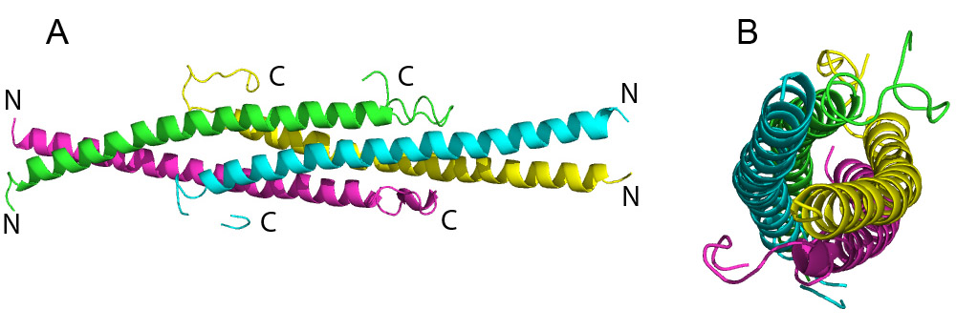

Figure1. An overall view of Yhcb homotetramer.

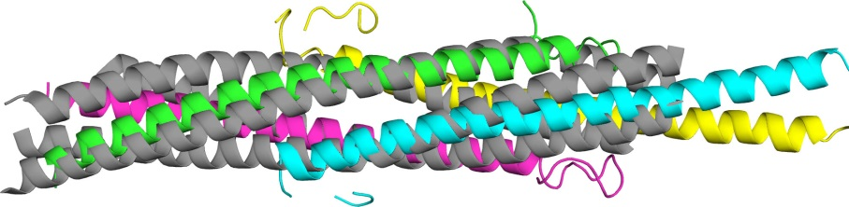

Figure 2. Superimposition YhcB (hdr25, colored as in Fig. 2) and yeast plasma membrane SNARE complex (grey, PDB ID 3b5n).

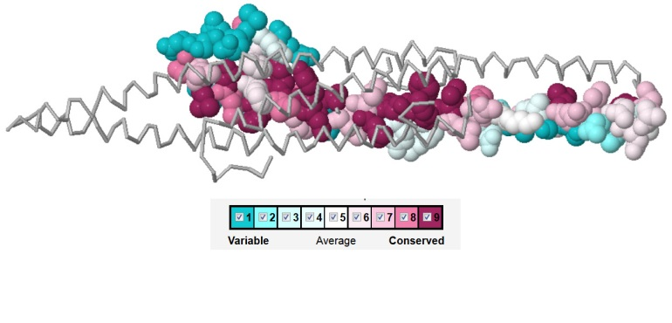

Figure 3. Residues of YhcB colored by conservation score (just one A protomer is shown)

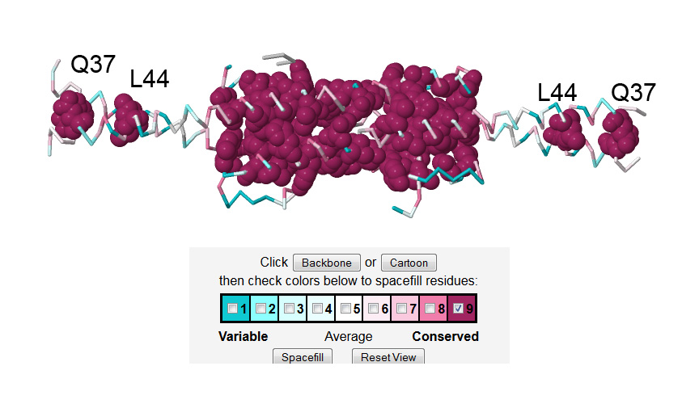

Figure 4. Location of highly conservative residues for all four protomers form homotetramer (ConSurf results).

Residues suggested for mutagenesis:

From structural point of view most interesting are residues involved in homotetramer oligomerization and highly conservative. They are His61, Phe62, His82, Phe83, and Ser65. They form a very tight patch in tetramer (figure 5b). Big question is if the homotetramer exists *in vivo* or it is a crystallization artefact. From aggregation screening we know that hdr25 is a monomer, but possible that *in vivo* local concentration are higher and some unknown conditions are facilitate the oligomerization. Very interesting is highly conservative Ser87 – it unfortunately locates in ill-defined part of density map, but possibly involves in hydrogen-pi interaction with Phe62. Other candidates are Leu90 and Asn86 which are located close to the His-Phe patch (L90) or form a hydrogen bond to Phe61 (N86).

To second group of mutations could be assigned highly conservative residues which not directly involved in coiled-coil homotetramer conformation based on the x-ray structure. They are Tyr76 and Ty80 – both are invariant in all sequences, but a reason they are so conservative is unclear from the structure. We could suspect that these Tyrs are important for regulation, but specific mechanism is needed to be studied. Less interesting residues in this group are Leu68, Leu69, and Asp75.

All suggested residues are located close to C-termini (figure 4). There are conservative Q37 and L44 close to transmembrane helix, but possible they are important for interaction with membrane, not for coiled-coil formation.

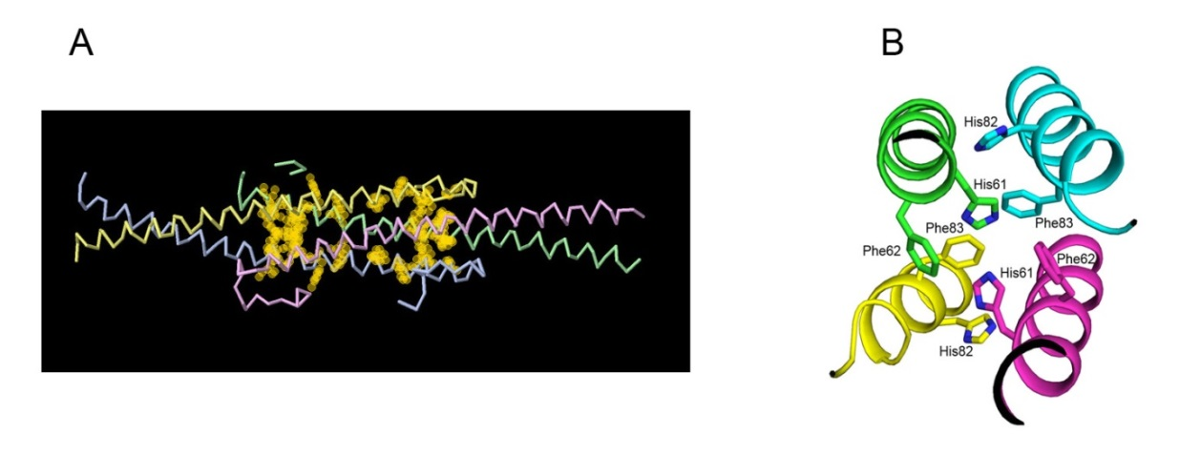

Figure 5. (A) A halo presentation highly conservative residues suggested for site-directed mutagenesis (H61, F62, S65, Y76, Y80, H81, F82, and S87). (B) A view of a His-Phe conservative patch in homotetramer structure.

Possible YhcB binding partners:



Two proteins are very good candidates: YciS (lapA) and MreC from published data. They could form coiled-coil conformation (figure 6):

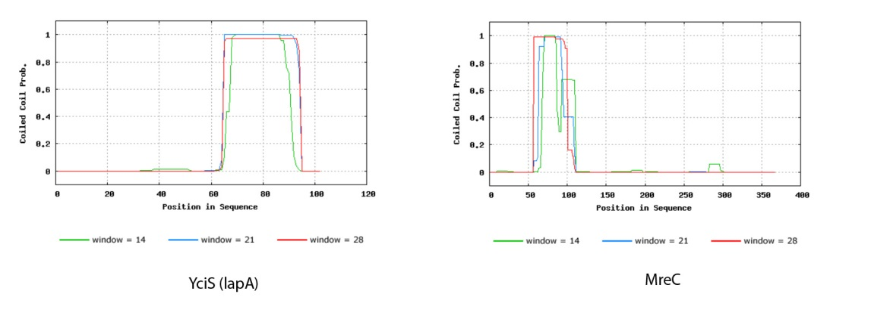

Figure 6. Results of probability analysis that YciS and MreC will adopt a coiled-coil conformation (Bioinforamtics Toolkit, Max-Plank Institute for Development Biology, <http://toolkit.tuebingen.mpg.de/pcoils> ).

Interesting that MreC has transmembrane helix similar in length with YhcB protein, but rest of the protein supposedly directed outside the membrane (figure 7). From this point of view YciS looks more attractive as its coiled-coil part directed inside the cell, similar to YhcB (figure 8).

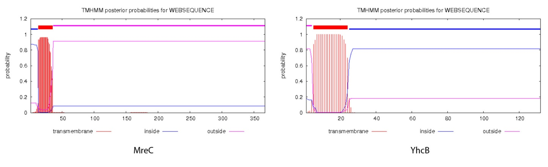

Figure 7. Result of prediction of transmembrane helices in MreC and YhcB proteins by TMHMM Server (<http://www.cbs.dtu.dk/services/TMHMM/> ).

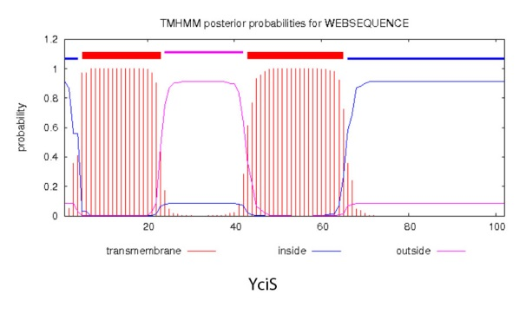

Figure 8. Prediction of probability of transmembrane helices in YciS protein.

Other possible candidates from unpublished data: kefA (mscK) (figure 9), fimA (from Strep. (MTSA_STRPA Manganese ABC transporter substrate-binding lipoprotein OS=Streptococcus parasanguinis GN=fimA), for some reason fimA from E.coli doesn't have coiled-coil potency), and, possible yidC (low coiled-coil probability). There is a new speculation that YhcB could interact with Fis, ihfA, and/or ybaB (all DNA binding proteins) based on evidences that removal of YhcB suppresses the long cell phenotype (Waldman et al., unpublished). From these proteins only one – ybaB has a potency to form coiled-coil conformation.

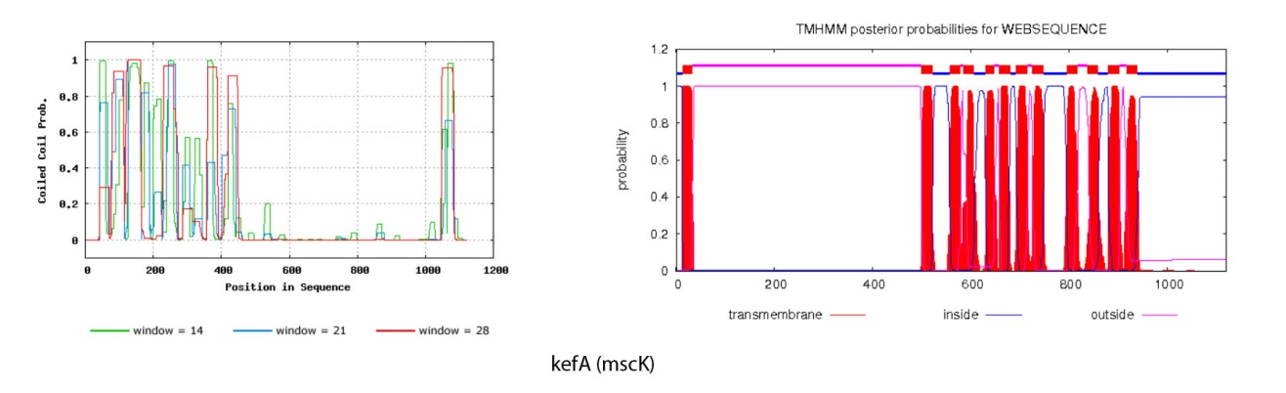

Figure 9. Prediction of coiled-coil and transmembrane helices probabilities for kefA (mscK) protein.